Math 1309-02 - Spring 2012
Review for Exam #2

Topics for Exam #2

- Chain Rule: power, exponential, and logarithmic functions
- Partial derivatives
- Application of partial derivatives to business, Douglas – Cobb model
- Graphing Functions using first ad second derivatives: critical points, intervals of increasing/decreasing, concavity, inflection points, x- and y- intercepts
- L’Hospital’s Rule for limits (indeterminate forms  and )
- Optimization problems; points of diminishing returns

Review Exercises.

- Use the product and quotient and chain rules to find each derivative
a)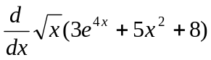 b)* 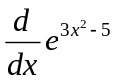 c) *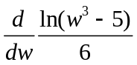 d)*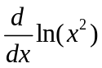 e)* 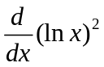 f)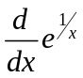

a)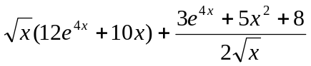 ; b) 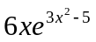 c) 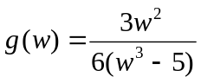 d)  e) 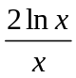 j) 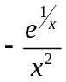

- Find the indicated partial derivatives, use the Product, Quotient, and/or Chain rules as needed. Do not simplify
a)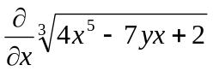 b) 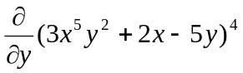 c) 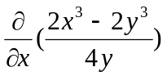 d) 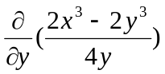
e) 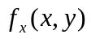 if 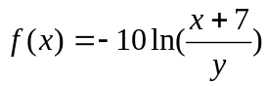 f) 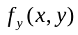 if 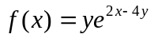

a) 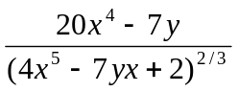 b) 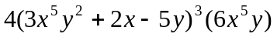 c) 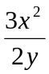 d) 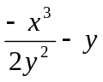 e) 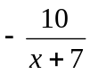
f) 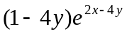

3. Use the: first and second derivatives to determine critical points, intervals of increasing/decreasing, points of inflection, intervals of concave up/concave down, and x- and y-intercepts to analyze each given function and sketch its graph. Label all important points and any horizontal and vertical asymptotes
a) 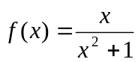 b) 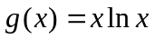 c) 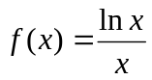 d) 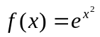
e) 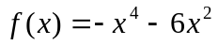 f) 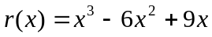

4. Problems 55, 57, and 59on page 628 (graphing using first derivative)

5. Problems 35, 36, and 39on page 645 (graphing using second derivative)

6. An inferior product with large advertising budget sells well when it is first introduced, but sales fall as people discontinue use of the product. Suppose that the weekly sales S are given by 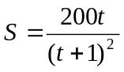 where S is in millions of dollars and t in weeks.
a) What will be the sales after 2 weeks?
b) Find the rate of change of the sales after 2 weeks. Are sales increasing or decreasing?
a) 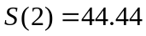 millions of dollars;
b) 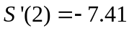, after 2 weeks sales are decreasing at a rate of 7.41 millions of dollars per week

7. Problems 83, 85, and 87on page 815 (applied problems on partial derivatives)

8. Determine the following limits, use or when appropriate. Use L’Hopital’s rule when needed.

a) 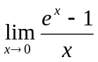 b) 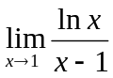 c) 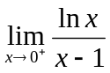 d) 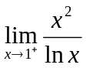 e) 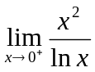 f) 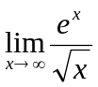
a) 1 b) 1 c) d) e) 0 f)

9. Problems 12, 13, 20, and 21on page 690 (optimization)

